Disability Network Chairs Development Program 2021

Strategy Session

Version 1.0 08/09/2021
Programme leads: Cavita Chapman (Head of EDI, NHS England and NHS Improvement), and Karol Leszek Kuczera (Psychotherapist, EDI Programme Manager, NHS England and NHS Improvement, South East)
Additional Program Delivery: Cath Baxter (Professional Voice Coach), and Cristina LaCara (Counsellor and Coach).
Data, analysis and reporting: Catherine McGill

Contents
1. Introduction 3
2. Purpose 4
2.1. Individual development 4
2.2. Organisational development 4
2.3. Workforce development 4
3. Programme structure and content 4
4. Evaluation 4
5. Session Content 5
6. Survey Feedback 5
6.1. Learning 5
6.2. Strategy 7
6.3. Confidence 8
6.4. Usefulness of the session 10
6.5. General Feedback 11

Introduction
The Disability Network Chairs Development Programme seeks to develop the
disability network leads’ confidence and skills in having a greater impact on
representing the voice of NHS staff with disabilities in their respective organisations
and systems.

The NHS staff have been tirelessly working through the biggest challenge ever faced
by the health care system. The pandemic has shone a light on pre-existing inequalities, and in many ways exacerbated them. Socio-economic factors, ethnic background, disability and age, have been found to play a huge role in increasing the likelihood of death from COVID. The Health Foundation’s report “The same pandemic, unequal impacts” (2020) suggested that people with disabilities were two to three times more likely to be affected by COVID than the non-disabled.

In over 1.3 million NHS workers, only about four per cent declare their disability status on the Electronic Staff Record (ESR), but a twenty-one per cent data gap is filled by the ‘unknown’ and ‘not disclosed’ categories (NHS Digital, 2021). Chairs of the Disability Networks play a crucial role in cultural development of an organisation by creating an inclusive and diverse working environment that encourages visibility,
respect and equity for staff with disabilities. The networks also provide a safe space
for staff to find connections with each other, share experiences, and promote ways to
raise and discuss concerns. However, organisational pressures, scarcity of resources, and a lack of dedicated time for network activities often become the cited barriers to the networks’ growth, and/or barriers to meaningful engagement from staff.

The Disability Network Chairs Development Programme (DNCDP) was launched in
February 2021 by the South East Equality, Diversity and Inclusion (EDI) team, and
was funded by NHS England and NHS Improvement’s Workforce Disability Equality
Standard (WDES). It sought to improve individual and organisational workforce
experience for the disability network leads by developing their skills and impact in
representing the voice of NHS staff with disabilities in their respective organisations
and systems. This programme was initially delivered over three 3-hour sessions by Karol Leszek Kuczera (Psychotherapist, EDI Programme Manager, NHS England and NHS Improvement, South East) and Cath Baxter (Professional Voice Coach). The sessions were evaluated to measure their efficacy, and to inform future development of programmes in the South East region. Following on, the DNCDP sessions continued to be delivered by Cavita Chapman (Head of EDI) and Cristina LaCara (Counsellor and Coach).

This report summarises the findings from the DNCDP session on Strategy and Operations by evaluating the quantitative and qualitative survey data gathered in a post-workshop survey.

Purpose
The Disability Network Chairs Development Programme (DNCDP) was designed to address three key areas:

Individual development
Research has shown that staff with disabilities are held back for a range of reasons
including lack of support for personal development, inconsistent appraisals with a
paucity of opportunities to explore their career aspirations and identify progression
opportunities. This programme sought to address this gap and provide a safe space
for staff with disabilities to assess their needs and develop confidence without fear.

Organisational development
This programme aimed to give network chairs and leads the opportunity to develop
skills to support their providers and ICS/STP to improve Disability equality, focus on
WDES actions and aspirations, and reduce disability-related health inequalities.
Disability Network Chairs and the wider disability staff network have historically been
used as a resource to inform Boards, HR, Freedom to Speak Up Guardians (FTSUG) and Staff Side about needs of staff with disabilities and methods for increasing engagement. To ensure organisations get the best support from Disability networks to reduce inequalities and widen staff with disabilities stakeholder engagement, we needed to ensure Disability Network Chairs have the skills to speak to key decisionmakers and communicate with confidence. This would help the rest of the workforce, which was our third theme.

Workforce development
Chairs of the Disability networks provide a steer for the network, help co-create a
psychologically safe environment for staff members, and question decision- and
policy-makers within the systems they operate. Therefore, developing Disability
Network Chairs plays an important role at directly and indirectly supporting the
workforce. This is achieved through highlighting to others their visibility and value, thus improving retention and attracting fresh staff into the NHS which supports our long-term plans to increase the workforce.

Programme structure and content
The structure is underpinned by the continuous improvement model and shaped by ongoing needs assessment that is captured from consultation with staff networks, surveys and review of themes from discussions in sessions. We will have input in our sessions from counselling psychologists, communication coaches, career coaches and those involved in developing leadership skills. Surveys are sent before and after sessions in order to assess the changes in confidence levels as well as the value of the sessions themselves.

Evaluation
The programme will be evaluated and reviewed at all stages. We will capture qualitative and quantitative data and share themes with researchers working in relevant fields. In general, NHS workforce development programmes are under-evaluated and that makes it difficult to measure efficacy, demonstrate value for the organisation and justify public sector expenditure.
The session on "Understanding the strategic landscape as a network chair" was held on 06/07/21 and there were 10 attendees. After the session attendees were asked to complete an evaluation survey. This report reviews those responses (6).

Session Content
The slides from the session are embedded below:
Feedback provided in the chat window during the session included:
- A good Exec Sponsor is so valuable. We have this too, for each of our networks
- I jump to asserting whenever people talk as if reasonable adjustments are favours or special concessions, rather than a legal obligation.
- I'm labelled as a trouble maker as I ask for equality
- start sentences with "As the chair of the staff disability network...." and talk about intersectionality
- I find I have to struggle being BAME and Disabled - It's a double whammy!
- This is a fun and free short course to recommend:
  - https://www.futurelearn.com/courses/exploring-intersectionality-and-what-makes-you-unique-with-kiddy-smile
  - Exploring Intersectionality & Privilege with Kiddy Smile - Course - FutureLearn. Explore how factors like race, gender, and sexuality intersect and affect our lived experience on this course led by Kiddy Smile and created with Tommy Hilfiger. www.futurelearn.com

Survey Feedback

Learning
The Chairs were asked to consider how they felt about what they learned, and this feedback was very positive.
When grading the quality of what they had learned in the session, the median grade given was 95%. Half of the respondents graded it at 100%, and the lowest was 70%.
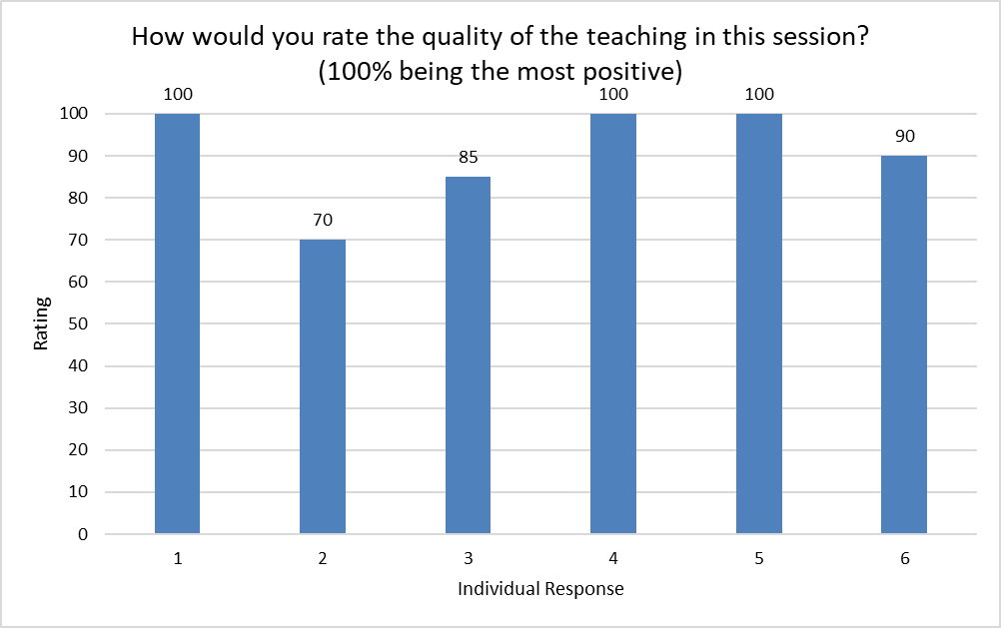

When considering the growth of their learning from this session, a third selected 100%, and the overall median score was 83%.
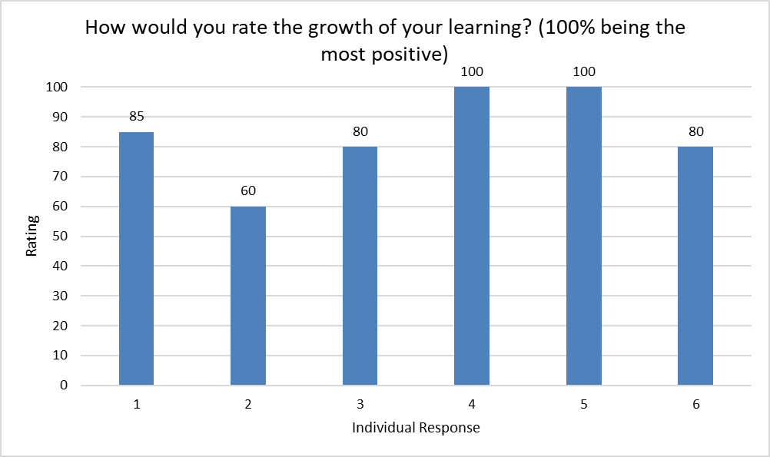
The only respondent who had not already tried out some of the new strategies learned commented that this was because they have been on sick leave, but they intend to do so when they return.
Of the Chairs who had tried out some of the strategies, 1 had received feedback that they were "being more positive and smiley".
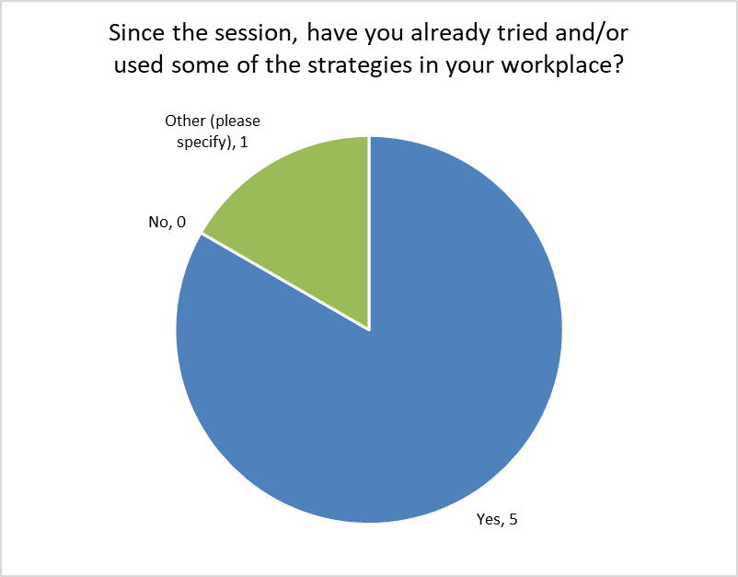

Strategy
The Chairs were asked about their familiarity with disability strategy in the NHS in and beyond their Trusts.
All of the Chairs are familiar with the disability strategy at their own Trusts, and half are also familiar with the national strategy. Only 1 Chair felt that they are familiar with the regional strategy but that individual did not note familiarity with the national strategy, so two thirds of them are familiar with strategy beyond their Trust. Nobody responded that they are familiar with their ICS strategy.
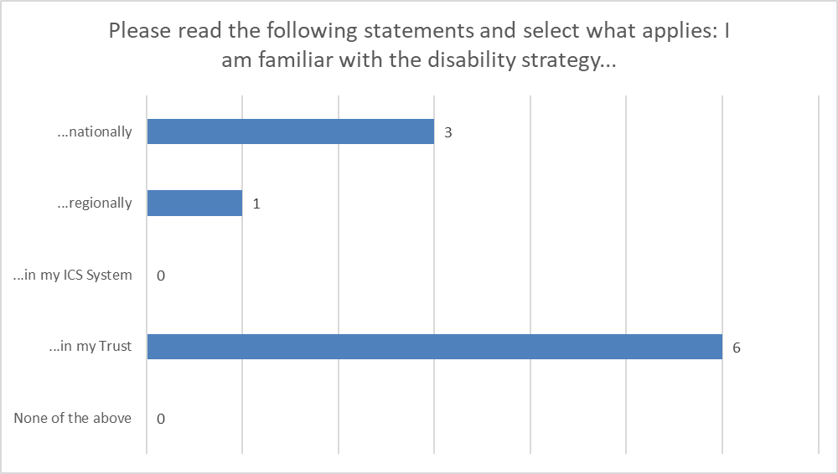

Confidence
The next set of questions asked about the Chairs' confidence levels following the session.
As there was a low number of returns, each individual response has been plotted in the following questions, and what we can see is that 1 Chair felt highly confident about everything, and 1 Chair was lower in confidence than the others in each of the questions. The person with lower confidence had indicated high ratings in the questions above around how helpful the training had been in improving their knowledge and confidence, so it can potentially be interpreted that their scores here are higher than they would have been without the training.
When thinking about their confidence in influencing or developing the strategy for their network, the scores were positive, yet mixed. 1 Chair was 100% confident, and the person with the lowest confidence level chose 55% - still in the top half. The median response was 75%.
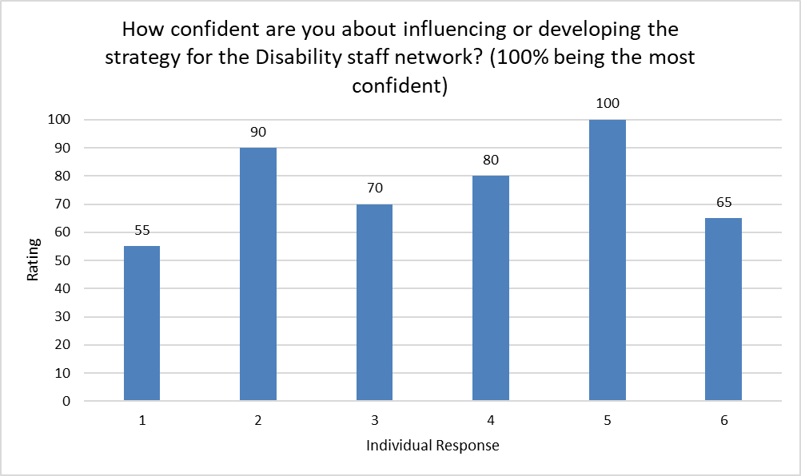
Confidence levels around forming strategic relationships with key stakeholders was a little lower, with a median of 70%. Again, 1 Chair felt fully confident at 100%, and though the other scores were a little lower than the previous question, most were still in the top half of the grading. 1 Chair was much less confident, with the lowest score being 40%.
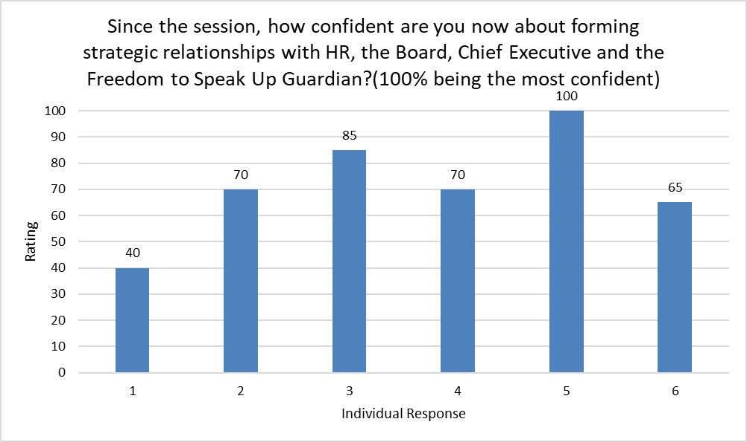

The improvement in their confidence levels from having this session were all positive, with 1 score again being 100%. The lowest score was 55%, and the median was 70%. So, it can be interpreted that all the Chairs felt that their confidence had been improved by the training.
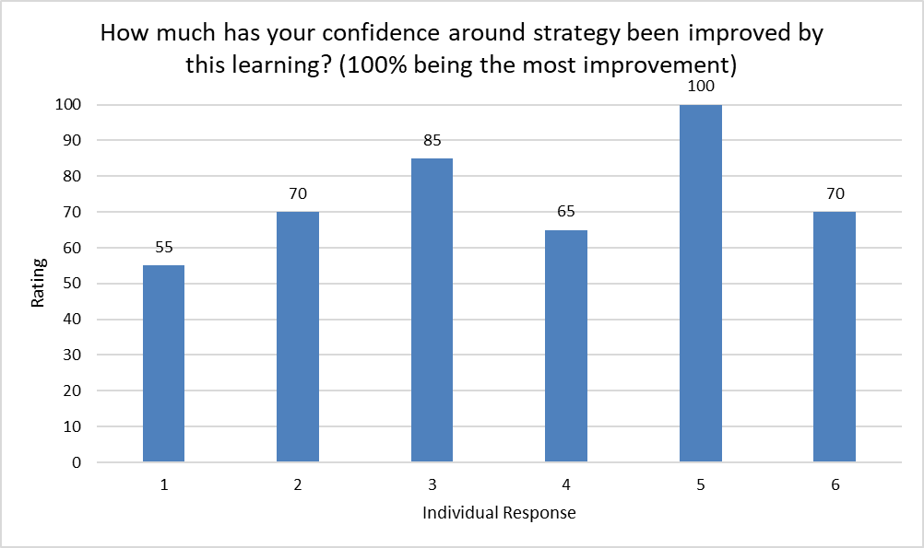

Usefulness of the session
The Chairs were asked to think about how this session might help with the Disability Network roles, and also in their own careers. They were also asked if there were things that could be improved on the program that would help their roles.
These were free text questions, and the responses provided are shown below.
Thinking about this training in relation to the Disability Networks roles, the responses were all about action - improving the network group, using co-production, influencing and challenging.
When considering their own careers, the Chairs were focussed on the improvement in their confidence and having additional - and transferable - skills that will support them with career development.
Suggestions around improving the program included 2 requests for 1:2:1 sessions. 1 Chair suggested input from the NHSE/I EDI team at their Disability Network meetings, and another considered adding practical application of the learning into the sessions.
Q - How could this strategy and influencing session help the Disability Network agenda or role?
- To help build a rigorous group to support those with a disability
- We could apply the national strategy of co-production to develop the EDI strategy within the Trust including the development of the Network
- It helps me work out who I need to approach and how to approach them
- Undertaking pioneering activities which can influence other Networks
- to have more of an impact and challenge the status quo
- guide my actions and build my confidence

Q - How could this strategy and influencing session help your career advancement?
- It has clarified to me I wish to work in this work stream and has given me the confidence to use my experience as a positive
- Develop as EDI Strategist
- it teaches me transferrable skills such as tying in the aims of my network in to the trust aims, and learning to take space to think before reacting
- Transferrable skills
- new skills and growing in leadership and confidence
- unsure

Q - What could we change or improve on this programme that will help your role?
- A short 1 to 1 would be brilliant
- Use each session to talk about how to apply strategy in a practical manner. For example, how to write a CV that ensures maximum impact.
- it's great so far!
- Maybe 1:1 coaching for specific areas of improvement
- Support from the team i.e. someone attending a disability meeting to talk about the national strategy
- unsure

General Feedback
The more general feedback on the program was positive and appreciative (2 Chairs left no further feedback).
Q - Is there any other general feedback you would like to share about the strategy session?
- These are brilliant sessions
- This was my first session. I had missed a lot of what happened over the previous session, but found it quite interesting.
- Thank you all
- I really appreciate these sessions - feels I am not alone

