Disability Network Chairs Development Program 2021

Giving and Receiving Feedback Session

Programme leads: Cavita Chapman (Head of EDI, NHS England and NHS Improvement), and Karol Leszek Kuczera (Psychotherapist, EDI Programme Manager, NHS England and NHS Improvement, South East)
Additional Program Delivery: Cath Baxter (Professional Voice Coach), and Cristina LaCara (Counsellor and Coach).
Data, analysis and reporting: Catherine McGill
Contents
Contents
1. Introduction 3
2. Purpose 4
2.1. Individual development 4
2.2. Organisational development 4
2.3. Workforce development 4
3. Programme structure and content 4
4. Evaluation 5
5. Session Content 5
6. Survey Feedback 13

Introduction
The Disability Network Chairs Development Programme seeks to develop the
disability network leads’ confidence and skills in having a greater impact on
representing the voice of NHS staff with disabilities in their respective organisations
and systems.

The NHS staff have been tirelessly working through the biggest challenge ever faced
by the health care system. The pandemic has shone a light on pre-existing inequalities, and in many ways exacerbated them. Socio-economic factors, ethnic background, disability and age, have been found to play a huge role in increasing the likelihood of death from COVID. The Health Foundation’s report “The same pandemic, unequal impacts” (2020) suggested that people with disabilities were two to three times more likely to be affected by COVID than the non-disabled.

In over 1.3 million NHS workers, only about four per cent declare their disability status on the Electronic Staff Record (ESR), but a twenty-one per cent data gap is filled by the ‘unknown’ and ‘not disclosed’ categories (NHS Digital, 2021). Chairs of the Disability Networks play a crucial role in cultural development of an organisation by creating an inclusive and diverse working environment that encourages visibility,
respect and equity for staff with disabilities. The networks also provide a safe space
for staff to find connections with each other, share experiences, and promote ways to
raise and discuss concerns. However, organisational pressures, scarcity of resources, and a lack of dedicated time for network activities often become the cited barriers to the networks’ growth, and/or barriers to meaningful engagement from staff.

The Disability Network Chairs Development Programme (DNCDP) was launched in
February 2021 by the South East Equality, Diversity and Inclusion (EDI) team, and
was funded by NHS England and NHS Improvement’s Workforce Disability Equality
Standard (WDES). It sought to improve individual and organisational workforce
experience for the disability network leads by developing their skills and impact in
representing the voice of NHS staff with disabilities in their respective organisations
and systems. This programme was initially delivered over three 3-hour sessions by Karol Leszek Kuczera (Psychotherapist, EDI Programme Manager, NHS England and NHS Improvement, South East) and Cath Baxter (Professional Voice Coach). The sessions were evaluated to measure their efficacy, and to inform future development of programmes in the South East region. Following on, the DNCDP sessions continued to be delivered by Cavita Chapman (Head of EDI) and Cristina LaCara (Counsellor and Coach).

This report summarises the findings from the DNCDP session on Strategy and Operations by evaluating the quantitative and qualitative survey data gathered in a post-workshop survey.

Purpose
The Disability Network Chairs Development Programme (DNCDP) was designed to address three key areas:

Individual development
Research has shown that staff with disabilities are held back for a range of reasons
including lack of support for personal development, inconsistent appraisals with a
paucity of opportunities to explore their career aspirations and identify progression
opportunities. This programme sought to address this gap and provide a safe space
for staff with disabilities to assess their needs and develop confidence without fear.

Organisational development
This programme aimed to give network chairs and leads the opportunity to develop
skills to support their providers and ICS/STP to improve Disability equality, focus on
WDES actions and aspirations, and reduce disability-related health inequalities.
Disability Network Chairs and the wider disability staff network have historically been
used as a resource to inform Boards, HR, Freedom to Speak Up Guardians (FTSUG) and Staff Side about needs of staff with disabilities and methods for increasing engagement. To ensure organisations get the best support from Disability networks to reduce inequalities and widen staff with disabilities stakeholder engagement, we needed to ensure Disability Network Chairs have the skills to speak to key decisionmakers and communicate with confidence. This would help the rest of the workforce, which was our third theme.

Workforce development
Chairs of the Disability networks provide a steer for the network, help co-create a
psychologically safe environment for staff members, and question decision- and
policy-makers within the systems they operate. Therefore, developing Disability
Network Chairs plays an important role at directly and indirectly supporting the
workforce. This is achieved through highlighting to others their visibility and value, thus improving retention and attracting fresh staff into the NHS which supports our long-term plans to increase the workforce.

Programme structure and content
The structure is underpinned by the continuous improvement model and shaped by ongoing needs assessment that is captured from consultation with staff networks, surveys and review of themes from discussions in sessions. We will have input in our sessions from counselling psychologists, communication coaches, career coaches and those involved in developing leadership skills. Surveys are sent before and after sessions in order to assess the changes in confidence levels as well as the value of the sessions themselves.

Evaluation
The programme will be evaluated and reviewed at all stages. We will capture qualitative and quantitative data and share themes with researchers working in relevant fields. In general, NHS workforce development programmes are under-evaluated and that makes it difficult to measure efficacy, demonstrate value for the organisation and justify public sector expenditure.
The session on "Giving and Receiving Feedback" was held on 07/09/21 and there were 10 attendees. After the session attendees were asked to complete an evaluation survey. This report reviews the 7 responses returned.

Session Content
Ali Jennings joined the session to talk about the Leadership Academy and how the Disability Network Chairs can assist them in becoming coaching volunteers.
They have 3 categories of programmes:
- Short leadership & management programmes which last for up 2 hours
- Espresso series
- leading transformation developing programme
They are currently working with 6 ICSs and Cavita Chapman on leadership development, with supportive actions around disability. There are Leadership Academy website shows events, and a Disability & co-production group.
Their virtual offers are open to everyone, and they have qualified coaches (faculty coaches) and cohorts that have been trained around race and are now offering coaching support for disability networks.
Discussion and feedback around this included talking about the belief that coaching volunteers will struggle to balance work and disability network role and can end up overworking. Ali responded that with the need to look for balance, there can be reduction in hours.
There was some discussion around the sunflower scheme, including a CCG which launched the sunflower scheme in November and created guidance on how it can be used virtually, including signature sign offs and virtual backgrounds. They offered to share this with the other networks.
One Chair said: Disability Network Chairs should be paid for their role rather than using their own time after work and at weekends. DNC don't have respect. I limit meetings to 1 hour over lunch so people don't feel guilty for attending. Also have key speakers at most sessions. I meet with the Chief Exec bi-monthly to discuss needs & wants. I have been contacted by HR regarding a stand-alone disability staff conference. MS Teams works, as the workforce is wide spread. We hope to gather in person at end of programme.
Ali recognised that there is a funding issue and will share feedback on how the journey can be shaped.
When thinking about virtual working, the attendees discussed that there needs to be a good practice guide to using MS Teams when booking in and sending coursework: using the camera, taking mute off when speaking etc., coursework should be sent in a format that is accessible to all, e.g. text size, Meetings should be limited to 2 hours with regular breaks and sticking to them. They considered how to record from MS Teams and ensuring that captions are recorded, along with the use of other tools e.g. whiteboards/Menti: when to use and how often.
Some staff are struggling with MS Teams and have guidance on how to help with virtual meetings, and how to coach/manage meetings when staff working from home and in the office.
Ali talked about hybrid working and agile working - and agreed to come back with some detail on how this will work in a new session to be arranged. Comments on hybrid working included:
- "hybrid working where those in the room will gain room privileges."
- "I see positive and negatives around hybrid or flexible working as our Trust are calling it. It seems that nobody can make a decision within our Trust of what to do and keep asking staff to ask what they want which is good but no decisions are being made about a yes or a no"
The session then continued using slides and coaching:
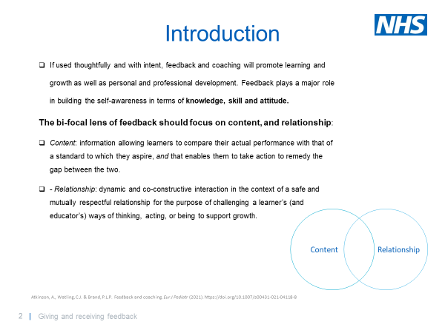
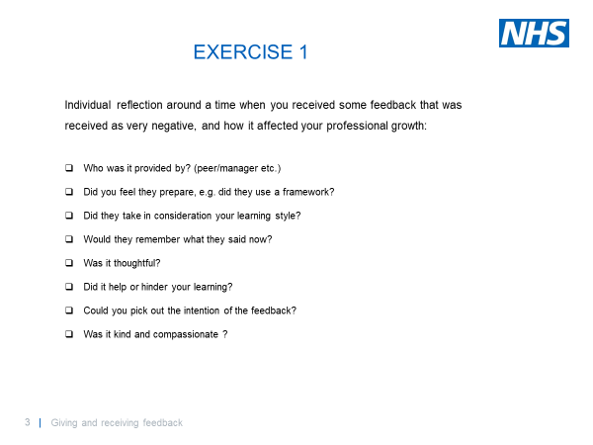
Comments and discussion on this first exercise included:
- Manager told her one Chair that they were quite rebellious. Asked for a breakdown as to why this was the right word to use.
- One Chair did a 360 review and asked if people could complete a survey. Review of the feedback led to a change in way how managed team as communication style required work, and the Chair is now a better manger following the review.
- One was asked by a lecturer if they had an attitude problem as they were always staring, but they were lip reading. Details of their disability had not been passed on, and the Chair is now conscious that people may find staring uncomfortable and will look away - therefore missing conversation as unable to lip read.
- Another said their Line manager said they were too sensitive. They are questioning how the environment effects how they work now.
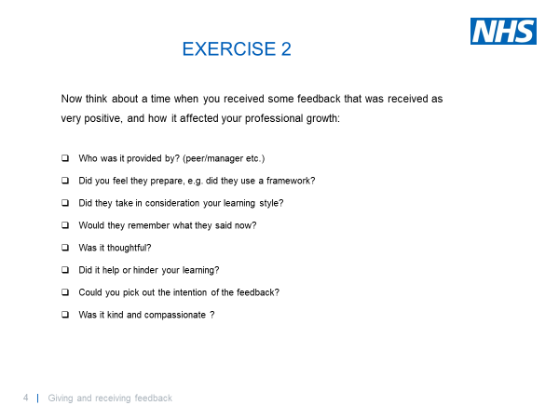
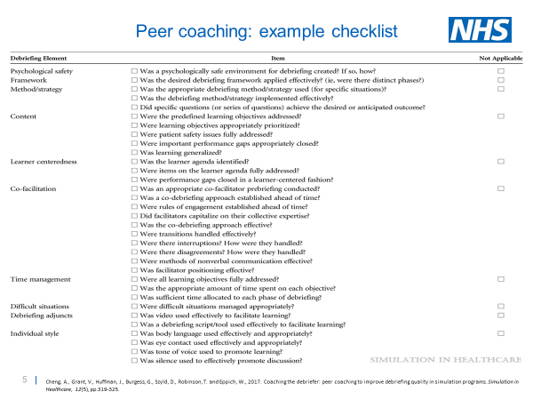
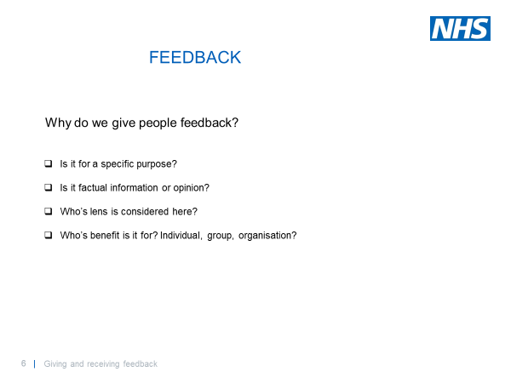
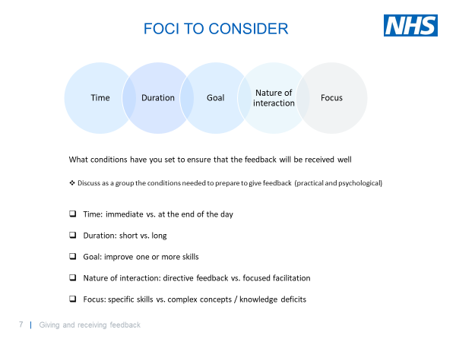
The group discussed why we give feedback, and the foci to consider:
- one of the reasons I think is that managers don't seem to be trained to do that job in the NHS. I worked for many more years out of the NHS than I have in and I have never worked for anywhere that didn't train and ongoing training too for those who wanted to be managers. In our organisation, you apply for the job of manager and that's pretty much it. They then rely on policies to do their managing for them but don't seem to be able to support the team they are leading as they don't seem to have support from above and so on throughout the line upwards. It's something I've been asking for a long time - which seems so basic an ask for me, to provide ongoing training for those who are now or want to be managers within our organisation. It just seems such an old-fashioned idea which again seems to be unique in the NHS.
- Should customise but not always appropriate to tell extent of negative feedback.
- Disabled people always try to be good as other people. When receives feedback has a feeling of not be good enough. Understand you might be uncomfortable talking about disability.
- A study carried out by the Institute of Corporate Productivity shows that 3 out of 4 employers ranked disabled employees to be just as good as—or even better than—others in terms of work quality, attendance and motivation. Most leading companies understand the importance and advantages of hiring disabled employees.
- How we receive feedback and how we give it. What assumptions are you making about the person and their behaviour

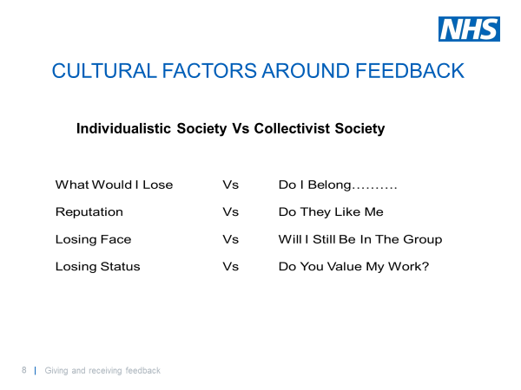
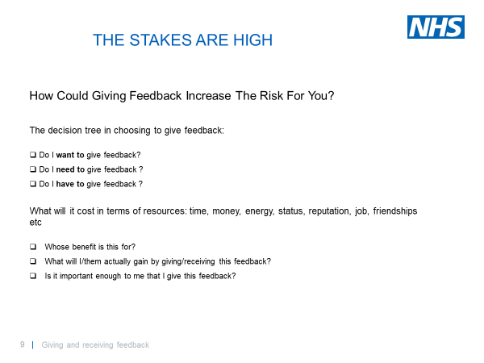
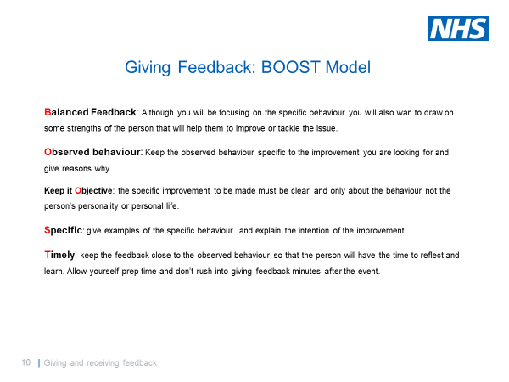
When considering giving feedback, the discussion included:
- Choose the right time and not a lengthy period after event.
- All succession managers should receive training e.g. Band 4 and above.
- Training needs to be mandatory.
- how about training for all managers, new, old and those wanting to be
- I've been asked to support people in disciplinary meetings
- The concept of giving feedback as 're-gifting'
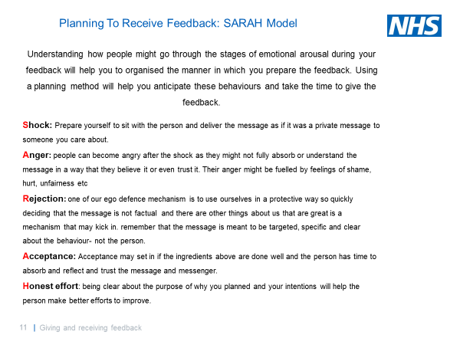
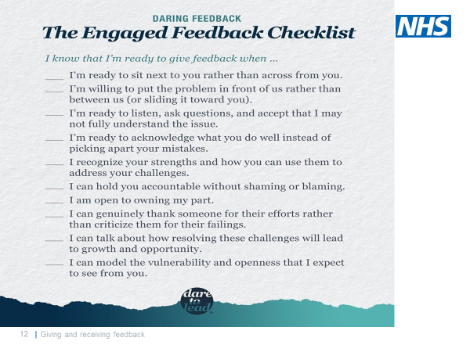
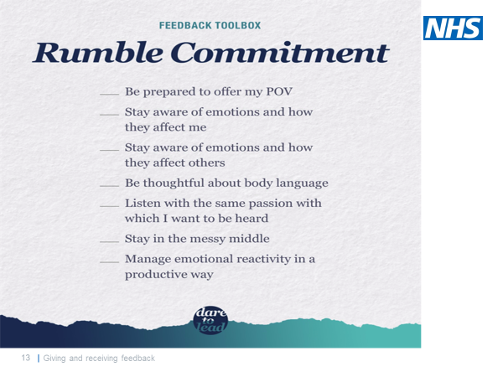
When thinking about overall feedback, the Chairs mentioned the following:
- Roll out support to all.
- Line managers have had training but still delivering feedback in the same manner.
- Appraisals should also include feedback on leaders.

Survey Feedback
The Chairs were asked to consider their experience of the session on a sliding scale.
One person scored the session just below midway (3), and the rest scored it 4 or 5, with the majority scoring at 5.
N=7
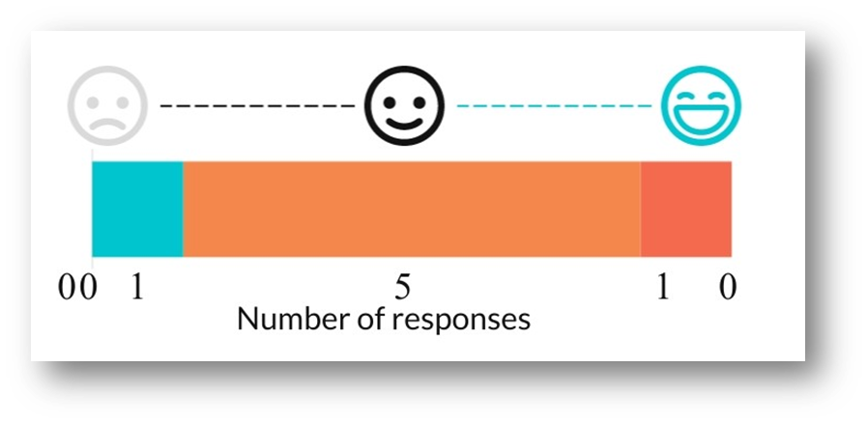
They were then asked to assess their learning from the session, with a variety of options to select. They could select more than one option if they felt it applied.
The majority of respondents selected most of the options available, which demonstrated a positive experience overall. All but 1 felt that they have a different mindset around feedback now, and the 1 person who did not select that, was one of the 4 who said that they feel more confident about giving and receiving feedback.
Overall the respondents felt able to reflect during the session, and that they have learned new concepts.
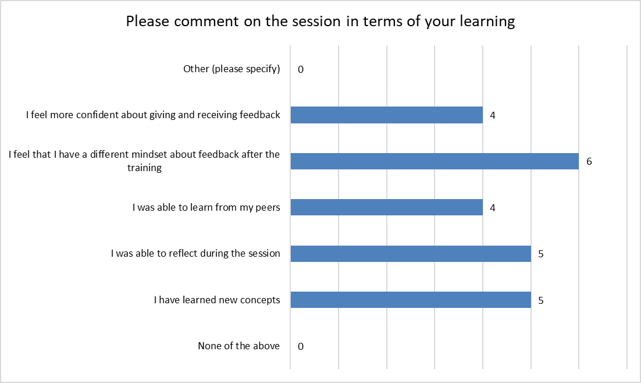

A similar scale to the one used above was used to ask about the peer to peer learning that they experienced during the session, and how useful they felt it was.
More than half (5) the respondents felt that it had been positively useful (scoring 4 or 5), though 1 scored it lower (3). This was the same respondent that scored the session itself 3 as well. For the other respondents, there was a slight shift to the higher score for this question, to 5 from 4.
N=7
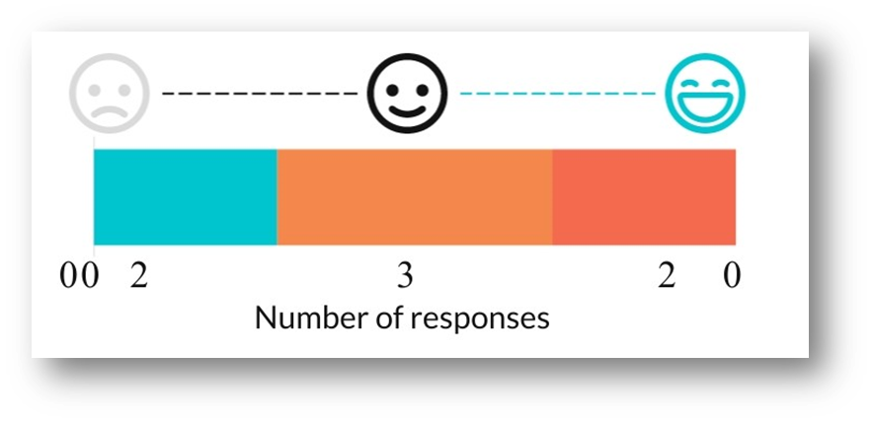
The attendees were then asked a few questions with free text for them to comment on the session. Selections of their comments on those questions follow.

Question: Please give any feedback on how we can improve the structure of the sessions.
There was some feedback around the length of the session, and wanting a longer break within it. One respondent hopes for a return to face to face sessions.
- give bit longer break like least 10 minutes as its 5 minutes I feel it is bit too short as especially I have stare at interpreter.
- At some point if safe and feasible, a face to face session could be useful particularly with getting to know the group better.
- timing
- all good thank you
There were also comments around how some people were asked to stay longer than the session had been planned for. For context, there was a psychological wrap-around planned for the session, which happens after Cavita's teaching. In this session there were only 10 min left for the psychological wrap around, so Cristina offered to stay on the call if people wanted more time. It was an optional offer, and the facilitators regret any misunderstanding around this.
- Towards the end of the session, several people were asked to stay behind and continue. This meant the session would over 2 hours which is extremely long time to be lip reading. Those who needed to lipread, had to leave the call - consequentially missing out. This approach meant a cohort of the members were excluded.
- We were asked to stay an additional half hour at the last minute, but the deaf attendees could not stay.

Question: Please share any personal learning insights you have taken away from this session.
The respondents were mostly reflective about how to plan giving feedback, with consideration for the person they are feeding back to.
- Reflect more in advance of feedback about how the recipient will feel
- Remember that the person in front has feelings and is as important as you!
- I appreciated the thought processes behind and structure of giving thoughtful and effective feedback.
- More conscious of providing feedback.
- Yeah as I will preparing if I receive or give the feedback and give it time.
- I would like to have more practical campaign support suggestions to apply back to my own network.

Question: Having attended the session what would you do differently in the future when giving or receiving feedback?
The respondents had a variety of thoughts around this question, with the main theme apparent being empathy for the other person. One person appreciated learning the BOOST method to add to their feedback toolkit.
- Prepare myself as to what the recipient might feel and prepare to respond appropriately to those feelings
- Thinking in the other person's shoes
- I would take more time to think empathetically about how the feedback will be received, and how it can be used to move forwards together.
- Use different way as BOOST as before the session I knew few such as sandwich system.
- Giving Feedback - Be mindful, be kind and stay focused on what the other person can do to shine Receiving Feedback - Would expect the same
- think about the points of reason and purpose etc
- I would ensure more time is protected.

