**National IAPT Webinar Series**

**BAME and COVID-19 Webinar- Thursday 21st May 2020**

**Speaker:** **Saiqa Naz** (CBT Therapist, Sheffield Specialist Psychotherapy Service, Build Modify Expand Lead), Chair, BABCP Equality and Culture Special Interest Group, IAPT BAME Positive Practice Guide

* Aims- to move away from stigma and complexity as reasons for not working appropriately/struggles with BAME communities and explore new ways of working online with interpreters.
* The information provided in this webinar works alongside all other previous IAPT webinars.
* Health inequalities is prevalent in austerity
* WRES Webinar:



* Data- no clarity on ethnicity on suicide rates, any available data should be compared with local Joint Strategic Needs Assessment data (JNSA), some communities may not be represented in the service. Quick win- start collecting 100% data on ethnicity and other protected characteristics.
* BAME people are suffering the impact of multiple losses:
  + Deaths/occupational hazards
  + Employment>implications of loss of employment
  + Experiences of lockdown/having COVID-19
  + Long term impact on physical health
* Funerals- People's view on life/death/hereafter
  + Muslim and Jewish communities raise concerns over forced cremations > burials, loved ones 'stuck' in limbo due to not getting an appropriate send off
  + Are family members experiencing guilt over not being able to see their families during these difficult times
  + Imagery- site visits may not be possible, so other images found online may need to be used to help people process their grief (refer to Traumatic Grief Webinar)
  + Sikhs- 'Antam Sanskar' includes family bathing and clothing the body at the funeral homes, community members may also come to pay their respects at a Gurudwara before the cremation
    - No community grieving can happen during COVID-19
* Aim to work with chaplaincy services/faith organisations to help with appraisals of seeking MH support during COVID 19, e.g. Imams in Islam may be able to reach out to members of the community more than non-BAME members of IAPT services
* Outreach work- joint webinars/groups with local faith organisations, making sure activities to replace funerals are culturally sensitive e.g. <https://www.bps.org.uk/coronavirus-resources/public/continuing-bonds>
* Issue of culture in organisations- are BAME staff experiencing bullying/harassment/discrimination, BAME communities and BAME therapists regularly being discriminated against in IAPT
  + Supporting BAME therapists- feel confident to challenge discriminatory behaviour through self/others, join BAME staff network groups, join the union, document issues
* Utilising IAPT BAME Positive Practice Guide (2019)- first version was published in 2009, however little has changed in advice over 10 years as potential work wasn’t acted upon
* V2 is now more comprehensive as BAME communities were consulted, however to implement work commissioners need to be more on board
* Working with interpreters remotely- set up confidentiality with interpreter as same way between therapist-client relationship, use the same platform, are private rooms available in patients own home? BAME people are more likely to live in shared housing, account for sessions to be a bit longer to ensure full dose of therapy is being achieved.
* Avoid constantly changing interpreters- same impact as constantly changing therapists/PWPs- disruptive to therapeutic relationship
* Remembering the nuances of different types of BAME backgrounds- e.g. refugees/asylum seekers vs migrants/british born BAME backgrounds

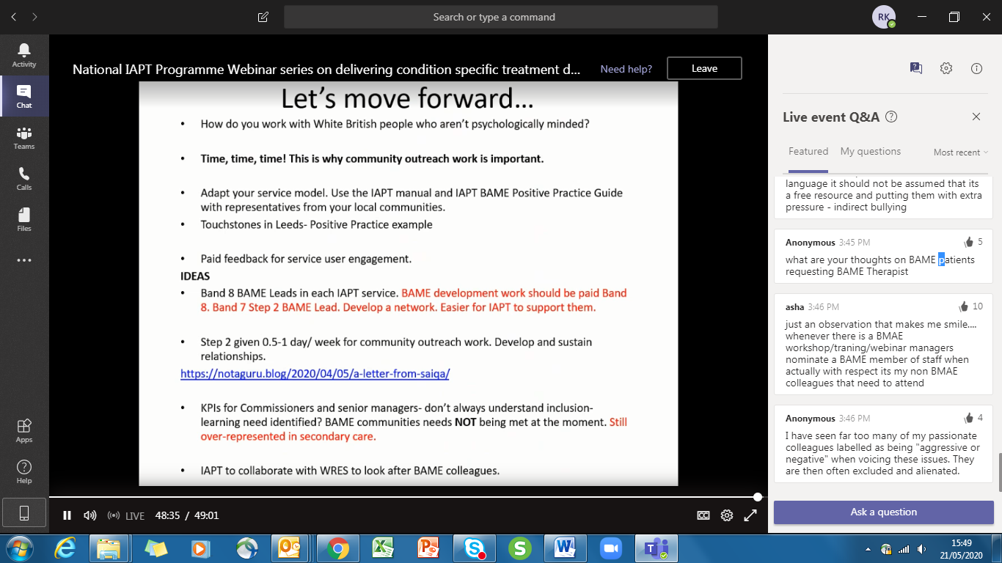

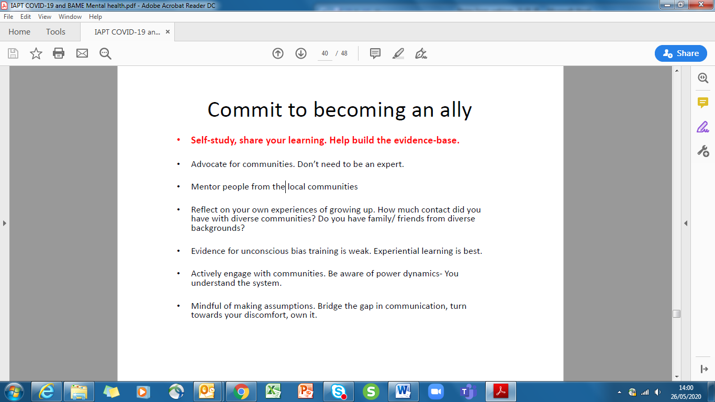

* Overcoming unconscious biases- have an awareness of festivals, check out interfaith week 2020 (8th-15th November 2020) <https://www.interfaithweek.org/>

Some relevant questions:

* Hi Saiqa - we have worked together on this. In the past, I have developed a plan to improve BAME work, which included a Band 8a Senior Prac, 2 Band 7 and 2 Band 6 PWPs, but the CCGs did not fund it. There needs to be buy in from commissioners as well. IAPT demand and capacity models are deigned on contacts and CCGs go to the lowest common denominator (£) rather than planning to assist with freeing up capacity to do this type of work and improving the quality of services. Has NHSE a view on this
* I am interested in your thoughts about creating a national IAPT group, comprising of regional IAPT networks to support with BAME workforce retention and wellbeing- to help support BAME members of staff feel safe and supported within their workplaces and ultimately stay with IAPT.