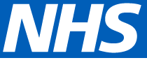
NHS England and NHS Improvement – Working together for the NHS
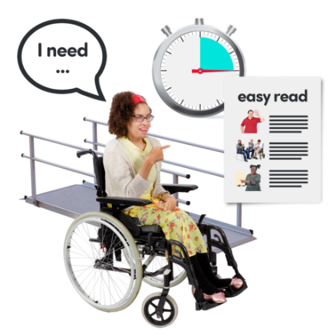
Reasonable Adjustments

My Plan for Work

Easy Read

This plan can come in other formats like braille or large print.
Please email england.diversity@nhs.net

This plan is to help disabled people at work.
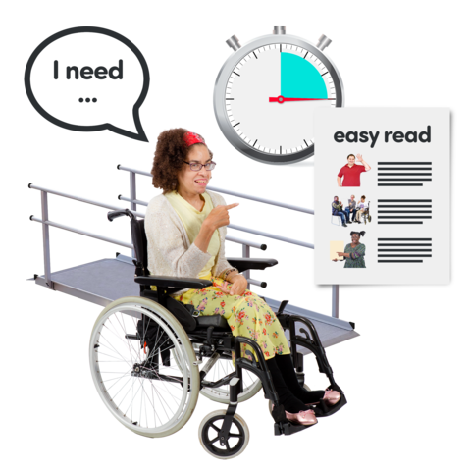

It is a place to write down your reasonable adjustments.

This means the support and changes you need to do your job.

You can take this plan with you, if you move teams or offices.

Or if you work with someone new, like a new line manager.

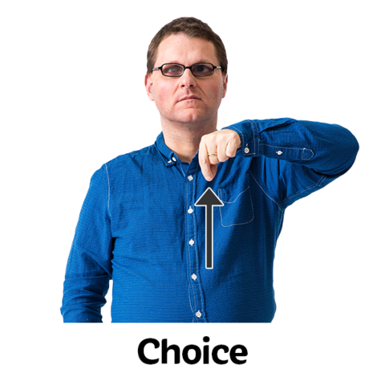
You can use this plan to explain what you need.

You do not have to use this plan. It is up to you.

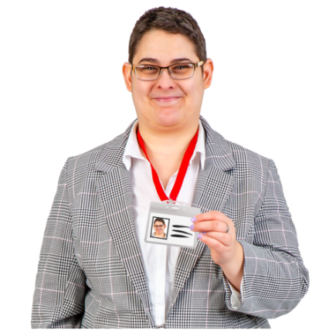
- What is your name and job?

- Who is your line manager?
- What helps you do the tasks in your job?
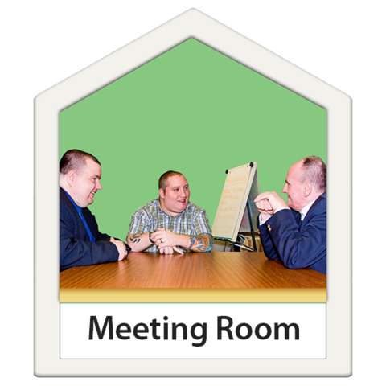

- In the office

- If you work from home

- If you travel for work

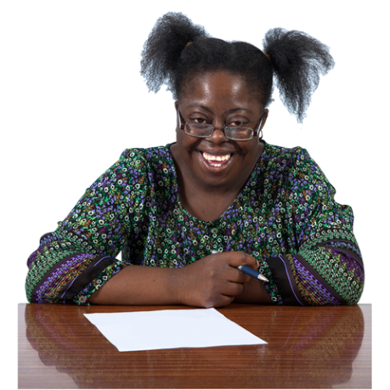
- What helps you to have a good day at work?

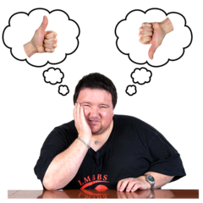
- What helps if you are having a bad day?

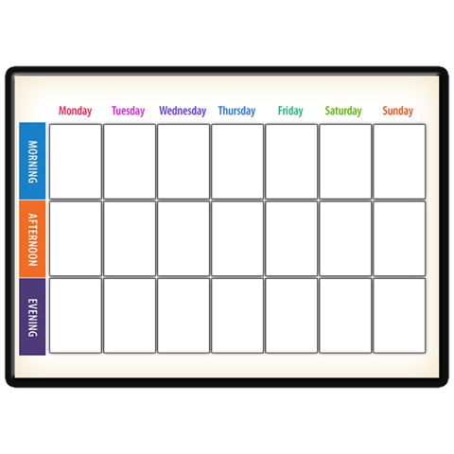
- Do you need to do things during work time to look after your health?

Things like:
- Take medicine

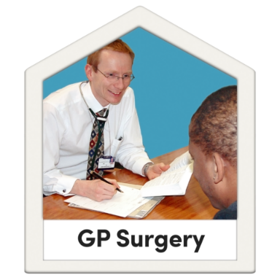
- Go to health appointments

What helps you do this?

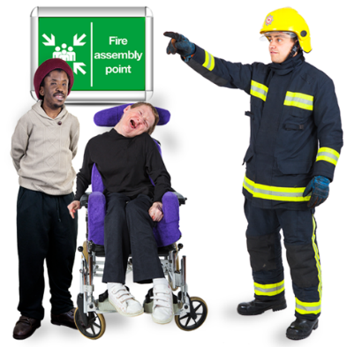

- If you need an Emergency Plan, make sure you have one.

Have you checked with your line manager?

- If you have had an assessment of your needs done by someone else, tell your line manager.

