BE THE CHANGE: A compassionate person-centred approach to supporting colleagues who are Black and Minority Ethnic (BME)
One of the most important things you can do on this earth is to let people know they are not alone. Shannon L. Alder
The current COVID-19 pandemic has shone a spotlight on the experiences of BME colleagues. For some this has been the retelling of a familiar story; for others an insight into a world that makes uncomfortable viewing. Whatever your perspective, the current situation speaks to a simple and pressing task – Change. Change both in terms of attending to the understandable heightened feelings of anxieties and vulnerability of BME colleagues due to the higher impact of COVID-19 on BME communities; and tackling the persistent inequalities experienced by many BME colleagues amplified by the current pandemic. And change happens when everyone plays their part, including the support of allies and people committed to building safe, inclusive and caring workplaces for all, and tackling head on the spectre of racial inequality.
Responding to the needs of your BME colleagues
It can be overwhelming when faced with a situation that initially feels unfamiliar, unsettling or uncomfortable. And sometimes people who feel overwhelmed also feel stuck. Unsure what to do for the best: where to start. So in these kind of situations we either do nothing, in the hope the problem will go away (which they rarely do) or, in an attempt to do something, reach for ‘quick fixes’ that can lack the nuance and sensitivity to the varied needs of BME colleagues. See also our curated article on Race Fluency in COVID-19 which explores this issue further.
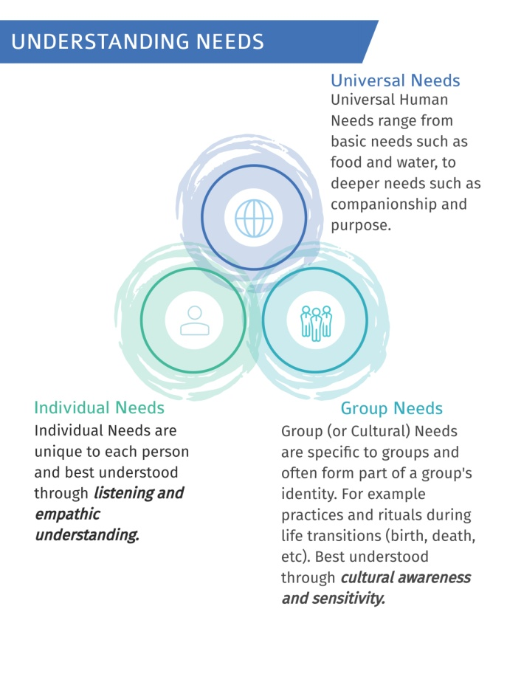
Reassuringly many of the skills needed to support our BME colleagues will be familiar to you: being person centred and flexible, acting with compassion, a commitment to fairness and inclusion, respecting and valuing others are all central to health and social care practice. So with this in mind there are many things you can do to be an ‘ally’ for your BME colleagues. Here are a few pointers.
Be Empathetic: ‘Listen to my Needs’
Everyone’s needs matter. Yet not everyone’s needs are the same. Some needs may be universal, yet others will be specific to certain groups and many others unique to that individual. As an ally, listening to and truly understanding your BME colleagues’ needs will guide your actions and help you work together to build a coalition for action. Currently your BME colleagues are talking about the need¹:
- To feel safe and secure
- To be heard and understood
- To be recognised and valued
- To feel welcomed and part of the team
- To be treated with respect and dignity
Find time to listen. Be curious. Be empathetic.

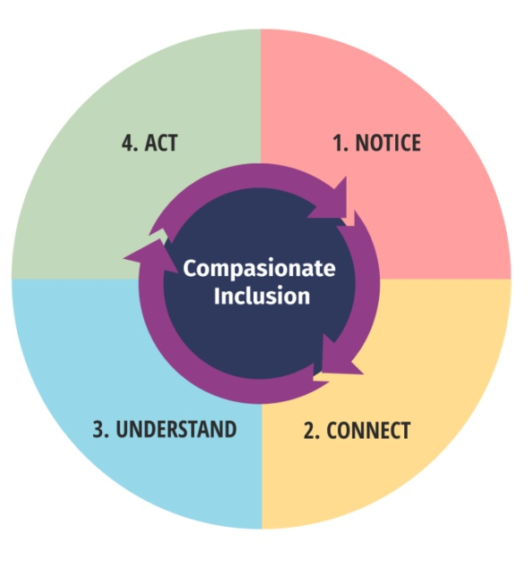
Act with Compassion: ‘Don’t feel sorry for me, do something’
- NOTICE: What’s happening to my BME colleagues? What’s their lived experience?
- CONNECT: Am I concerned about what I am hearing and seeing? Am I motivated to action?
- UNDERSTAND: What are my BME colleagues’ needs? What changes are required?
- ACT: What actions (personally and organisationally) can be taken to bring about the desired changes?
Compassion is an action not a sentiment. Action on inclusion also takes courage: the courage to ‘lean in’ to discomfort and to act with compassion rather than simply feeling sorry for someone. And even though feeling sorry for someone, or pity, is based on the belief that someone does not deserve to suffer, and involves paying attention to the suffering of others, it does not lead to significant action. Importantly, unlike pity, where a safe emotional distance from those suffering is maintained, compassion involves the willingness to become personally involved. Encouragingly compassion is both a familiar and accessible quality that can support you to move beyond feelings of concern and pity toward compassionate inclusive action and change.
Allyship: ‘Be part of the change’
Being an ally means being willing to own your mistakes and be proactive in your education. As you learn and grow and step into the role of an ally there are a few things you can do. Take it upon yourself to use the tools around you to learn and answer your questions about the work of equality and inclusion. Learn about yourself. For example be aware of your biases and how these can impact on your practice. Learn how to act as an advocate for colleagues whose voices go unheard. Figure out ways to change the system that leads to inequality. Remember your actions matter. Working out how best to act is part of the challenge of life long learning.
Compassionate action: ‘what can I do right now?’
Use the following template to plan how you can support your BME colleagues.
CONTINUE - what can I continue doing that is supportive of my BME colleagues? | STOP - what can I stop doing that might be contributing to creating a hostile, unsafe or unsupportive environment for my BME colleagues?
START - what can I start doing that will contribute to creating a supportive workplace for my BME colleagues? | SUPPORT - what support do I need to be an effective ‘ally’ for my BME colleagues?
Based on request for information on the experience of BME colleagues and action taken by South East Health and Wellbeing COVID-19 programme in May 2020. Feedback was supplied by:
- BRAP and NHS Trust NEDS
- BME Focus Group
- Various Trusts, CCGs and networks within the South East
- Return to work interviews being conducted more interrogatively towards BME staff
- BME staff experiencing micro-aggressions from staff
- BME staff experiencing racist comments from the public
- Public fears being transferred onto BME staff – public being more aggressive and racist towards BME staff who are looking after their loved ones
- The culture of some trusts, don’t value staff – and this is more illuminated in these times of urgency
- Impact assessments for Muslims who are observing Ramadan
- Need to condemn racist behaviour explicitly – both overt and covert - at organisation level, but also nationally
- More education for white staff – they still don’t know the impact of their behaviour
- The general feeling of the group is a reluctance to raise concerns for fear of reprisals in the future. This is a common and ongoing theme but this has heightened as of late. There are no concerns about availability of PPE but there was a recall of PPE which caused concern.
- (BME) People are feeling really isolated, for a number of reasons (they may not have family in the country or because their day job is working on the frontline they are having to isolate) and this is taking its toll on people. It was also noted that a high proportion of BME staff are joining webinars to simply share how they are and connect with others.
- Stress is really high in BME communities right now. Do people have case studies of what’s working/ or what EDI and HWB leads can do together.
- Early in April it became apparent that BME Staff / people were disproportionately impacted by Covid-19, I proposed to the Senior Leadership Team that we make personal contact with our BME staff to better understand the impact on them, specifically, I wanted to know about our staff and their families wellbeing, whether were doing everything we can to support them and significantly whether their PPE and “shielding” needs were being met. Our CEO approved this action and tasked 2 Senior Managers to make personal calls to our BME staff (160) and provide staff with direct access to those Senior managers. The outreach was well received by our BME staff, they expressed gratitude, including comments such as “I am proud to be a part of this organisation”.
- Opinion of staff network leads were sorted before action plans agreed. Networks were keen for the Trust to drive the initiative from centre rather than silo action from network.
- Our company sent a letter to all BME staff. Although well received by BME colleagues, I am yet to receive any positive feedback from non-BME members of staff. The only feedback received has been negative, thus far. The fragmentation between the letter and availability of a new risk assessment caused unease but the thought was to get a letter of support out first (so people feel reassured) and the risk assessment was to follow. The managers were disconcerted. They felt flummoxed at the uncertainty of having these conversations. “Training” for a few key managers will take place next week and the information will be disseminated from there.
- At [Trust anonymised] we have included BME staff in vulnerable group and a risk assessment will be done on every individual for the same. We have taken into consideration the scientific evidence so far available. We have also introduced a guide for managers to have those conversations with BME staff. It is challenging to have many conversations with BME staff due to work force capacity. But it is the right thing to do for welfare of BME staff. More solid evidence regarding the impact of COVID on BME population / systemic studies and evaluation is needed which will then make it easier to have the discussions with all staff involved.
Actions that some NEDS are recommending at their trusts. Letter to all BME staff will include:
- Acknowledgement & acceptance of data
The SE HWB C19 team are considering all the feedback we have received in order to improve the inclusivity of our approach to our current and ‘normal’ roles.
We invite you to join us.

- Review of our procedures and guidelines e.g. PPE management, testing to see if it adversely affects group
- Close monitoring of emerging research.
- Setting up series of virtual meetings for BME staff to discuss experiences/concerns. Will be attended by at least 50% of above-named personnel.
- New dedicated email address for staff to voice concerns. Also making sure other lines of communication are open and well publicised

